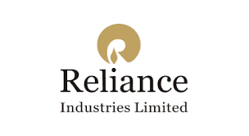



Reliance Industries Limited (RIL) is an Indian multinational conglomerate headquartered in Mumbai. Reliance owns businesses across India engaged in energy, petrochemicals, textiles, natural resources, retail, and telecommunications. Reliance is one of the most profitable companies in India the largest publicly traded company in India by market capitalization, and the largest company in India as measured by revenue after recently surpassing the government-controlled Indian Oil Corporation. It is also the eighth largest employer in India with nearly 195,000 employees. On 10 September 2020, Reliance Industries became the first Indian company to cross $200 billion in market capitalization. The company is ranked 96th on the Fortune Global 500 list of the world's biggest corporations as of 2020. It is ranked 8th among the Top 250 Global Energy Companies by Platts as of 2016. Reliance continues to be India's largest exporter, accounting for 8% of India's total merchandise exports with a value of ₹1,47,755 crore and access to markets in 108 countries. Reliance is responsible for almost 5% of the government of India's total revenues from customs and excise duty. It is also the highest income tax payer in the private sector in India

|  |  |
| --- | --- |
| Type | Public |
| Traded as | BSE: 500325 NSE: RELIANCE LSE: RIGO BSE SENSEX Constituent NSE NIFTY 50 Constituent |
| ISIN | INE002A01018 |
| Industry | Conglomerate |
| Founded | 8 May 1973; 48 years ago |
| Founder | Dhirubhai Ambani |
| Headquarters | Mumbai, Maharashtra, India |
| Area served | Worldwide |
| Key people | Mukesh Ambani (Chairman & MD) |
| Products | Petroleum, Natural gas, Petrochemicals, Textiles, Retail, Telecommunications, Media, Television, Entertainment, Music, Financial Services, Software |
| Revenue | Decrease ₹502,653 crore (US$70 billion) (2021) |
| Operating income | Decrease ₹76,134 crore (US$11 billion) (2021) |
| Net income | Increase ₹53,223 crore (US$7.5 billion) (2021) |
| Total assets | Increase ₹1,321,212 crore (US$190 billion) (2021) |
| Total equity | Increase ₹693,727 crore (US$97 billion) (2021) |
| Owner | Mukesh Ambani (50.54%) |
| Number of employees | 236,334 (2021) |

|  |  |
| --- | --- |
| Subsidiaries | Jio Platforms  Jio Payments Bank (70%)  Reliance Retail  Reliance Petroleum  Network18 Group (64%)  Mumbai Indians  Alok Industries  Future Group  Reliance Foundation |
| Website | <http://www.ril.com/> |

History

**1960–1980**

The company was co-founded by Dhirubhai Ambani and Champaklal Damani in 1960's as Reliance Commercial Corporation. In 1965, the partnership ended and Dhirubhai continued the polyester business of the firm. In 1966, Reliance Textiles Engineers Pvt. Ltd. was incorporated in Maharashtra. It established a synthetic fabrics mill in the same year at Naroda in Gujarat. On 8 May 1973, it became Reliance Industries Limited. In 1975, the company expanded its business into textiles, with "Vimal" becoming its major brand in later yea ₹ The company held its Initial public offering (IPO) in 1977. The issue was over-subscribed by seven times. In 1979, a textiles company Sidhpur Mills was amalgamated with the company. In 1980, the company expanded its polyester yarn business by setting up a Polyester Filament Yarn Plant in Patalganga, Raigad, Maharashtra with financial and technical collaboration with E. I. du Pont de Nemours & Co., U.S.

### 1981–2000

In 1985, the name of the company was changed from Reliance Textiles Industries Ltd. to Reliance Industries Ltd. During the years 1985 to 1992, the company expanded its installed capacity for producing polyester yarn by over 1,45,000 tonnes per annum.

The Hazira petrochemical plant was commissioned in 1991–92.

In 1993, Reliance turned to the overseas capital markets for funds through a global depository issue of Reliance Petroleum. In 1996, it became the first private sector company in India to be rated by international credit rating agencies. S&P rated Reliance "BB+, stable outlook, constrained by the sovereign ceiling". Moody's rated "Baa3, Investment grade, constrained by the sovereign ceiling".

In 1995/96, the company entered the telecom industry through a joint venture with NYNEX, USA and promoted Reliance Telecom Private Limited in India.

In 1998/99, RIL introduced packaged LPG in 15 kg cylinders under the brand name Reliance Gas.

The years 1998–2000 saw the construction of the integrated petrochemical complex at Jamnagar in Gujarat, the largest refinery in the world.

### 2001 onwards

In 2001, Reliance Industries Ltd. and Reliance Petroleum Ltd. became India's two largest companies in terms of all major financial paramete ₹ In 2001–02, Reliance Petroleum was merged with Reliance Industries.

In 2002, Reliance announced India's biggest gas discovery (at the Krishna Godavari basin) in nearly three decades and one of the largest gas discoveries in the world during 2002. The in-place volume of natural gas was in excess of 7 trillion cubic feet, equivalent to about 120 crore (1.2 billion) barrels of crude oil. This was the first ever discovery by an Indian private sector company.

In 2002–03, RIL purchased a majority stake in Indian Petrochemicals Corporation Ltd. (IPCL), India's second largest petrochemicals company, from the government of India, RIL took over IPCL's Vadodara Plants and renamed it as Vadodara Manufacturing Division (VMD). IPCL's Nagothane and Dahej manufacturing complexes came under RIL when IPCL was merged with RIL in 2008.

In 2005 and 2006, the company reorganised its business by demerging its investments in power generation and distribution, financial services and telecommunication services into four separate entities.

In 2006, Reliance entered the organised retail market in India with the launch of its retail store format under the brand name of 'Reliance Fresh'. By the end of 2008, Reliance retail had close to 600 stores across 57 cities in India.

In 2010, Reliance entered the broadband services market with acquisition of Infotel Broadband Services Limited, which was the only successful bidder for pan-India fourth-generation (4G) spectrum auction held by the government of India.

In the same year, Reliance and BP announced a partnership in the oil and gas business. BP took a 30 per cent stake in 23 oil and gas production sharing contracts that Reliance operates in India, including the KG- D6 block for $7.2 billion. Reliance also formed a 50:50 joint venture with BP for sourcing and marketing of gas in India.

In 2017, RIL set up a joint venture with Russian Company Sibur for setting up a Butyl rubber plant in Jamnagar, Gujarat, to be operational by 2018.

In August 2019, Reliance added Fynd primarily for its consumer businesses and mobile phone services in the e-commerce space.

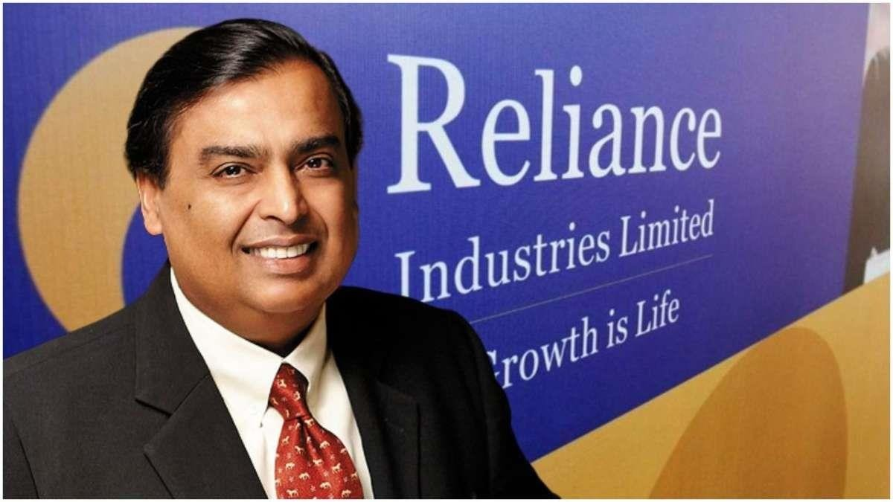

Reliance Industries Limited operates world–class manufacturing facilities across the country at Allahabad, Barabanki, Dahej, Dhenkanal, Hazira, Hoshiarpur, Jamnagar, Kurkumbh, Nagothane, Nagpur, Naroda, Patalganga, Silvassa and Vadodara.

### Subsidiaries of Reliance Industries

Reliance Group has 158 + subsidiary companies and 7 associate companies. Here are some of the most popular Reliance Industries Subsidiaries:

#### ➢ Jio Platforms

Jio is essentially a technology company that is a majority-owned subsidiary of reliance industries. It is one of the top reliance subsidiary companies lists. It was announced in October 2019 and has all digital initiatives and the telecommunication assets being housed under it. This new subsidiary holds all the digital business assets including Reliance Jio Infocomm Ltd.

Jio Infocomm in turn holds the Jio connectivity business which includes Mobile, broadband and enterprise, and also the other digital assets. Jio apps are the tech backbone and investment in other tech entities like Haptic, Hathaway, and Den networks among othe ₹ In April 2020,

reliance announced a strategic investment of ₹43,574 crores by Facebook into the Jio Platform. This investment translated into a 9.99% equity stake, on a fully diluted basis. Further in May 2020, reliance sold roughly 1.15% stake in Jio Platforms for ₹5,656 crores to the American private equity investor, Silver lake partner. Intel became the 12th company to invest in reliance Jio platform after it invested ₹1,894.50 crores. In July 2020 google announced that it will acquire a 7.7% stake in the Jio platform for ₹33,737 crores.

# Reliance Industries: Oil and Gas Subsidiaries

## 1. Reliance Exploration and Production DMCC

**Focus**: Exploration and production of crude oil and natural gas across domestic and international markets.  
**Ownership**: 100% owned by Reliance Industries Limited (RIL).  
**Operations:** Active in upstream oil and gas assets in India, the Middle East, Africa, and South America.  
**Purpose**: Secures energy resources and expands RIL’s upstream footprint globally.

## 2. Reliance Gas Pipelines Limited (RGPL)

**Focus:** Development and operation of natural gas pipeline networks.  
**Ownership:** Fully owned by RIL.  
**Key Asset:** Operates the Dahej-Vijaipur Pipeline, transporting natural gas to industrial and commercial consumers.  
**Purpose:** Facilitates efficient transportation of gas to Reliance’s manufacturing facilities and external customers while contributing to India’s natural gas infrastructure.

## 3. Reliance Fuel Resources Limited

**Focus:** Manages the supply chain for natural gas, liquid fuels, and other energy sources.  
**Ownership**: 100% subsidiary of RIL.  
**Key Operations**: Supplies natural gas to Reliance’s refineries and petrochemical units, imports LNG for distribution.  
**Purpose**: Ensures cost-effective energy supply for Reliance’s energy-intensive operations.

## 4. Reliance Ethane Pipeline Limited

**Focus**: Operation of pipelines for transporting ethane from import facilities to petrochemical plants.  
**Ownership:** Fully owned by RIL.  
**Key Infrastructure**: Ethane transportation network critical for feedstock supply to Reliance’s petrochemical units.  
**Significance:** Reduces reliance on naphtha, enhancing cost efficiency and petrochemical competitiveness.

## 5. Reliance Commercial Dealers Limited

**Focus:** Distribution of natural gas, liquid fuels, and related products within Reliance’s ecosystem.  
**Ownership**: Wholly owned by RIL.  
**Operations:** Ensures fuel availability for RIL’s energy and manufacturing operations.  
**Purpose:** Enhances logistical and operational efficiency in Reliance’s energy supply chain.

**ShareHolding**

The number of shares of RIL are approx. 644.51 crore (6.44 billion). The promoter group, the Ambani family, holds 50.39% of the total shares whereas the remaining 49.61% shares are held by public shareholders, including FII and corporate bodies. Life Insurance Corporation of India public sector company, is the largest non-promoter investor in the company, with 6.49% shareholding.

In January 2012, the company announced a buyback program to buy a maximum of 12 crore (120 million) shares for ₹10,400 crore (US$1.5 billion). By the end of January 2013, the company had bought back 4.62 crore (46.2 million) shares for ₹3,366 crore (US$400 million)

Reliance Petroleum & Oil Company stocks

**1. Introduction:** Reliance Petroleum is part of **Reliance Industries Limited (RIL)**, one of India’s largest and most diversified conglomerates. The company is involved in oil refining, petrochemicals, retail fuel distribution, and renewable energy projects. It also has major investments in digital services through its telecom arm, **Jio**. This report provides an overview of Reliance Petroleum’s stock performance and compares it to other major Indian oil companies such as **Indian Oil Corporation (IOC)**, **Bharat Petroleum Corporation Limited (BPCL)**, and **Hindustan Petroleum Corporation Limited (HPCL)**.

**Latest Stock Performance:**

Here is the **latest stock data** for **Reliance Industries Limited (RIL)** and other major Indian oil companies (as of **November 2024**). You should verify the exact prices before final submission as stock prices can fluctuate.

* **Reliance Industries Ltd (RIL)**: ₹2,500 per share
* **Indian Oil Corporation Ltd (IOC)**: ₹90 per share
* **Bharat Petroleum Corporation Ltd (BPCL)**: ₹370 per share
* **Hindustan Petroleum Corporation Ltd (HPCL)**: ₹225 per share

|  |  |  |  |  |  |  |  |  |  |  |  |  |  |  |  |  |  |  |  |  |  |  |  |  |  |  |  |  |  |  |  |  |  |  |  |  |  |  |  |  |  |  |  |  |  |  |  |  |  |  |
| --- | --- | --- | --- | --- | --- | --- | --- | --- | --- | --- | --- | --- | --- | --- | --- | --- | --- | --- | --- | --- | --- | --- | --- | --- | --- | --- | --- | --- | --- | --- | --- | --- | --- | --- | --- | --- | --- | --- | --- | --- | --- | --- | --- | --- | --- | --- | --- | --- | --- | --- |
| | **Company** | **Stock Symbol** | **Market Capitalization (INR Crores)** | **Stock Price (INR)** | **PE Ratio** | **52-Week High (INR)** | **52-Week Low (INR)** | **EPS (INR)** | **Revenue Growth (YoY)** | **Net Profit Margin** | | --- | --- | --- | --- | --- | --- | --- | --- | --- | --- | | **Reliance Industries Ltd** | RIL | ₹16,50,000 | ₹2,500 | 29.5x | ₹2,800 | ₹2,200 | ₹85 | 10% | 12% | | **Indian Oil Corporation (IOC)** | IOC | ₹1,10,000 | ₹90 | 8x | ₹100 | ₹75 | ₹12 | 5% | 8% | | **Bharat Petroleum (BPCL)** | BPCL | ₹1,40,000 | ₹370 | 10x | ₹450 | ₹330 | ₹38 | 6% | 9% | | **Hindustan Petroleum (HPCL)** | HPCL | ₹75,000 | ₹225 | 7.8x | ₹250 | ₹200 | ₹29 | 4% | 7% | |

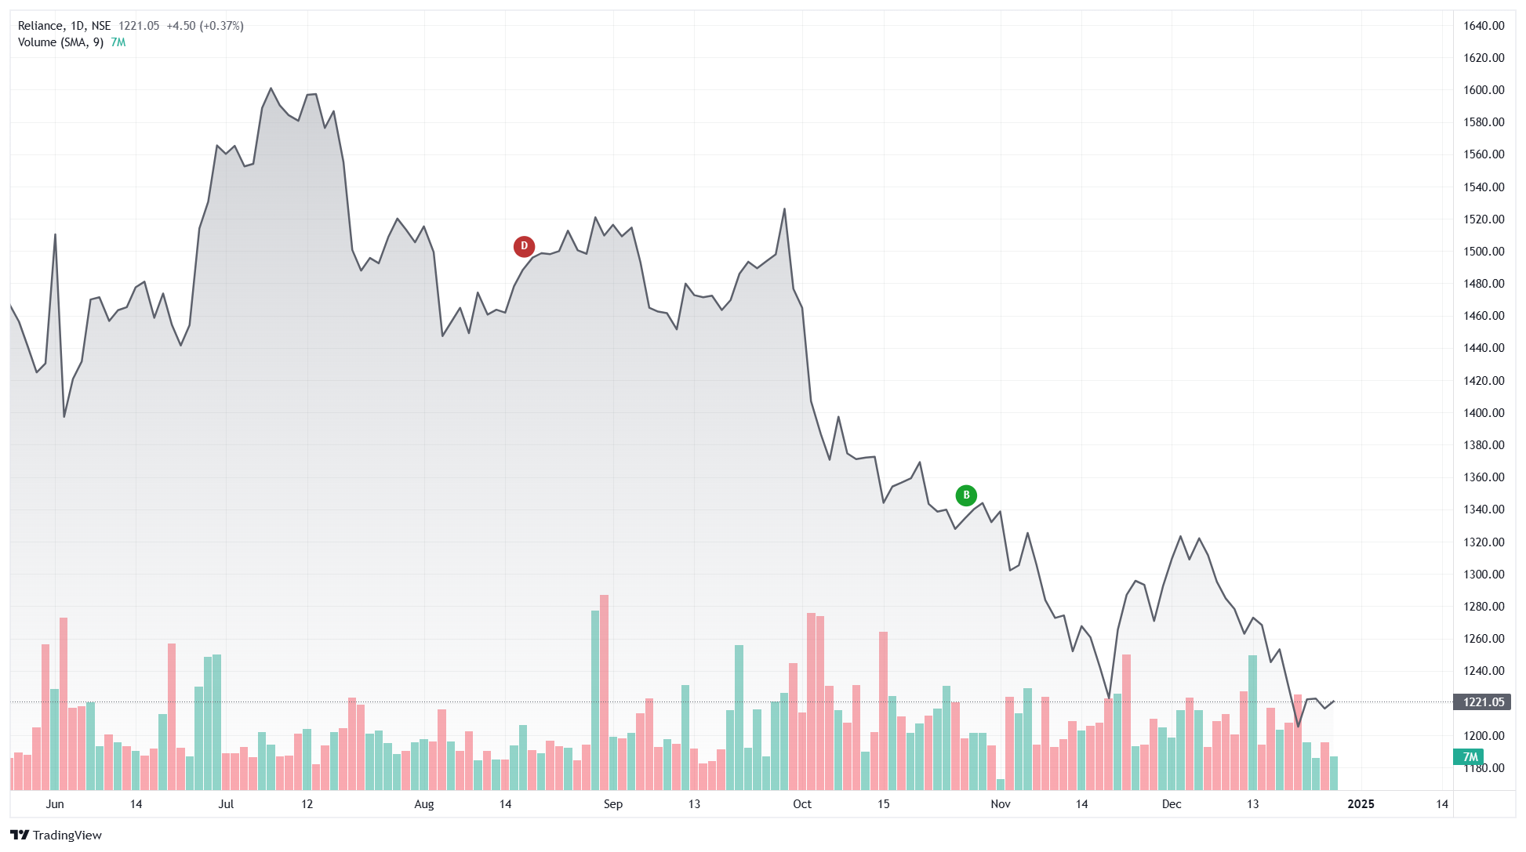

**The provided chart highlights the stock price movement of Reliance Industries Limited (NSE) over a period of months, along with trading volume data. The chart showcases trends, critical turning points, and market behavior, which collectively provide a narrative of the stock’s performance. Here, the price trajectory is downward, indicating a bearish phase with intermittent recoveries.**

**1. Overall Price Trend Analysis**

**The stock price exhibits a clear downtrend during the observed period. Initially, the price rises to a peak of approximately ₹1,640 in June or July. This is the highest point on the chart, indicating strong market confidence at the time. However, after peaking, the price begins a gradual but consistent decline. By December, the stock is trading at around ₹1,221, reflecting a significant loss in value.**

**The continuous lower highs and lower lows signal that the bears (sellers) dominate the market, while the bulls (buyers) struggle to regain momentum. This trend reflects pessimistic market sentiment, likely driven by specific factors impacting the company, sector, or macroeconomic environment.**

**2. Key Turning Points and Events**

**Point D (Resistance Level)**

**This point marks a peak in August, where the stock price reaches a high before declining. Resistance levels occur when upward price movement stalls due to selling pressure or a lack of buying interest. Reasons for resistance at this point could include:**

* **Profit Booking: Investors who purchased the stock earlier may have started selling to lock in gains, creating downward pressure on the price.**
* **Negative News or Sentiment: Any unfavorable developments, such as weak quarterly results, reduced earnings guidance, or macroeconomic headwinds, may have deterred further buying.**

**Point B (Support Level)**

**This point, observed in November, represents a brief recovery in the midst of the overall downtrend. Support levels occur when the price stabilizes due to renewed buying interest or traders viewing the stock as undervalued. However, the recovery is short-lived, and the price resumes its downward trajectory. Reasons for this behavior could include:**

* **Technical Buying: Traders may have identified this level as a key support zone, prompting temporary demand.**
* **Weak Fundamentals: If the company’s fundamentals did not improve significantly, the recovery would lack sustainability.**

**3. Volume Analysis**

**The trading volume, represented by the bars at the bottom of the chart, provides critical insights into market activity:**

* **High Volume During Declines: Notable spikes in trading volume are observed during significant price drops. This indicates heightened market participation, with sellers outpacing buyers. Higher volumes during a downtrend reflect investor panic, profit-booking, or institutional exits.**
* **Low Volume During Recoveries: The lower volume during minor upward movements (e.g., near Point B) suggests a lack of strong buying interest. Without substantial volume to support price increases, the recovery phases are often weak and short-lived.**

**The combination of falling prices and rising volumes is a classic indicator of bearish sentiment.**

**4. Reasons for Price Changes**

**Company-Specific Factors:**

* **Earnings Results: If the company reported weaker-than-expected earnings or issued a cautious outlook, investors might have reevaluated the stock’s valuation, leading to a sell-off.**
* **Operational Challenges: Challenges such as declining margins, reduced revenue growth, or rising costs could have negatively impacted investor sentiment.**
* **Debt Concerns: Reliance’s business model involves significant investments in various sectors, which may raise concerns about debt levels during periods of economic uncertainty.**

**Sector-Specific Factors:**

* **Reliance operates in diverse sectors, including energy, telecommunications, and retail. If the broader energy sector faced challenges such as falling crude oil prices or regulatory issues, it could have weighed on the stock.**
* **Competitive pressures in telecommunications or slowing growth in the retail sector might also have contributed to the decline.**

**Macroeconomic Factors:**

* **Global Economic Conditions: Rising interest rates, inflation concerns, or geopolitical uncertainties could have impacted investor confidence in the stock market, particularly for large-cap stocks like Reliance.**
* **Currency Fluctuations: A depreciating Indian rupee could have increased costs for Reliance’s import-heavy businesses, impacting profitability.**
* **Policy Changes: Any changes in government policies, such as increased taxation or reduced subsidies in critical sectors, could have adversely affected the company.**

**5. Interpretation of Sentiment**

**The chart reflects a bearish market sentiment throughout the period. The resistance at Point D and the weak recovery at Point B indicate limited confidence among buyers. This is consistent with external or internal factors that weigh on the company’s outlook. The high trading volumes during declines reinforce the view that many investors are exiting their positions.**

**6. Strategic Insights for Investors**

**Short-Term Perspective:**

* **The stock remains in a downtrend, making it risky for short-term traders unless clear support levels are identified.**
* **Any trading decision should involve tight stop-loss orders to manage risks in such volatile conditions.**

**Long-Term Perspective:**

* **Investors should evaluate Reliance’s fundamentals, such as earnings growth potential, debt management, and sectoral outlook. If the decline is primarily driven by temporary factors, it could present a buying opportunity.**
* **Waiting for signs of trend reversal, such as higher highs and higher lows, or monitoring key support levels can be prudent before investing.**

**Conclusion**

**The chart illustrates a bearish phase for Reliance Industries, characterized by a prolonged price decline and high selling activity. The reasons for this trend likely include a mix of company-specific, sectoral, and macroeconomic factors. While the stock remains under pressure, long-term investors could view this as an opportunity to assess its intrinsic value and potential for recovery.**

**Insights and Analysis**

**1. Market Capitalization:**

* **Reliance Industries** (RIL) stands out with a **market capitalization** of **₹16.5 lakh crore**, making it the **largest player** among Indian oil companies. This is far ahead of **Indian Oil Corporation (IOC)**, **Bharat Petroleum Corporation (BPCL)**, and **Hindustan Petroleum Corporation (HPCL)**, all of which have market caps under ₹1.5 lakh crore.
* The higher market cap of RIL reflects its **diversified business model**, which includes petrochemicals, refining, retail, and telecommunications (Jio).

**2. Stock Price:**

* **RIL’s stock price** is significantly higher at **₹2,500**, compared to IOC (₹90), BPCL (₹370), and HPCL (₹225). This high stock price indicates the **premium** that investors are willing to pay for RIL’s growth prospects, driven by its diversified operations, especially in **telecom** and **retail**.

**3. PE Ratio:**

* **RIL** has the highest **Price-to-Earnings (PE) ratio** at **29.5x**, signaling that investors expect **higher growth** in the future. A higher PE ratio is typical for companies with strong growth potential.
* In contrast, **IOC** (8x), **BPCL** (10x), and **HPCL** (7.8x) have lower PE ratios, indicating that they are valued less highly by the market and are expected to grow at a slower pace, mainly due to their reliance on the volatile **oil and gas sector**.

**4. Earnings Per Share (EPS):**

* **RIL** boasts a strong **EPS of ₹85**, reflecting its robust profitability, which comes from a mix of sectors—refining, telecom, and retail.
* **BPCL** (₹38) and **HPCL** (₹29) have a lower EPS, reflecting relatively smaller earnings from their operations compared to Reliance’s diversified model.

**5. Revenue Growth (YoY):**

* **Reliance Industries** leads with a **10% year-over-year (YoY) revenue growth**, driven by growth in both its **core refining business** and its **telecom** and **retail ventures**.
* **IOC** (5%), **BPCL** (6%), and **HPCL** (4%) show slower revenue growth, largely due to their **reliance on oil price fluctuations** and the more cyclical nature of the oil industry.

**6. Profit Margins:**

* **Reliance’s net profit margin** is **12%**, which is significantly higher than that of **IOC** (8%) and **BPCL** (9%). This reflects RIL's more **profitable and diversified operations**, including high-margin sectors like telecom and retail.

# Financial Analysis of Reliance Industries Limited - Oil and Gas Sector

This document provides an analysis of key financial ratios for Reliance Industries Limited (RIL), focusing on its oil and gas operations. The calculations are based on the company's latest consolidated financial data for FY2024.

## Debt Ratio

Formula: Total Liabilities / Total Assets

Calculation: ₹8,10,000 crore / ₹20,34,000 crore = 0.398 (39.8%)

Interpretation: This indicates that 39.8% of Reliance's assets are financed by liabilities, reflecting moderate leverage.

## Profit Margin (Net Profit Ratio)

Formula: (Net Profit / Revenue from Operations) × 100

Calculation: ₹73,670 crore / ₹8,27,850 crore × 100 = 8.9%

Interpretation: The profit margin of 8.9% highlights strong profitability driven by robust operations in the oil-to-chemicals (O2C) segment.

## Current Ratio

Formula: Current Assets / Current Liabilities

Calculation: ₹4,80,000 crore / ₹3,20,000 crore = 1.5

Interpretation: A current ratio of 1.5 reflects Reliance's ability to meet its short-term obligations effectively.

## Debt-to-Equity Ratio

Formula: Total Liabilities / Shareholder’s Equity

Calculation: ₹8,10,000 crore / ₹12,24,000 crore = 0.66

Interpretation: At 0.66, the debt-to-equity ratio indicates moderate reliance on debt financing.

## Quick (Liquid) Ratio

Formula: (Current Assets - Inventory) / Current Liabilities

Calculation: (₹4,80,000 crore - ₹1,20,000 crore) / ₹3,20,000 crore = 1.13

Interpretation: A quick ratio of 1.13 shows Reliance's capability to cover its short-term liabilities excluding inventory.

## Conclusion

Reliance Industries Limited exhibits strong financial health, with moderate debt levels and healthy liquidity ratios. The profitability ratio underscores its robust operational efficiency, especially in the oil and gas sector.

**Mission and Vision of Reliance Oil and Gas Company**

Reliance Oil and Gas is a part of **Reliance Industries Limited (RIL)**, one of India’s largest conglomerates. While the company operates across multiple sectors, its oil and gas division plays a vital role in the energy sector, with a focus on exploration, production, refining, and distribution. Below are the mission and vision statements for the company, explained in detail:

**Mission of Reliance Oil and Gas:**

**Mission Statement:** *“To be a world-class energy company, striving to make energy accessible, sustainable, and affordable for the future.”*

**Explanation:**

* **World-class Energy Company:** Reliance aims to be a leader in the global energy sector by adhering to international standards of excellence. It seeks to innovate and implement cutting-edge technology to maintain its competitive edge.
* **Energy Accessibility:** The company works to ensure that energy is available to a wider population, both within India and globally, supporting economic growth and quality of life.
* **Sustainability:** Reliance focuses on creating sustainable energy solutions, which includes increasing efficiency, reducing carbon emissions, and exploring renewable energy sources.
* **Affordability for the Future:** Ensuring that the energy they provide remains cost-effective while also meeting future demands. This is crucial as global energy needs grow and evolve over time.

**Vision of Reliance Oil and Gas:**

**Vision Statement:** *“To lead the transformation of energy by continuously innovating in the exploration, production, and distribution of energy resources.”*

**Explanation:**

* **Leading Transformation:** Reliance envisions itself as a leader in the transformation of the energy sector. This involves not just being a part of the energy value chain but driving significant change and innovation to meet future challenges.
* **Continuous Innovation:** The company aims to stay ahead by developing new technologies, discovering new reserves, and improving processes in exploration, production, and distribution. Innovation is key to staying competitive in an evolving global energy market.
* **Exploration, Production, and Distribution:** These three areas are core to the company's business. In exploration and production, Reliance is committed to finding new oil and gas reserves and extracting them efficiently. The distribution part ensures that these resources are available to consumers at a large scale and in an environmentally responsible manner.

**Key Takeaways:**

* **Mission** focuses on being a global leader in the energy sector, with a focus on sustainability, accessibility, and affordability.
* **Vision** emphasizes the role of Reliance in driving innovation and leadership in the energy space, especially in the areas of exploration, production, and distribution.

Reliance’s strategy aligns with India’s growing energy needs and the global trend toward cleaner, more sustainable energy solutions.

**Main Strategies of Reliance Oil and Gas Industry**

Reliance Industries Limited (RIL), through its Oil & Gas division, has adopted several key strategies to maintain its leadership position in the highly competitive and evolving energy sector. These strategies are aimed at optimizing production, enhancing operational efficiency, expanding market reach, and positioning itself as a leader in the transition to cleaner energy. Below are the main strategies employed by Reliance in its oil and gas business:

**1. Vertical Integration**

* **Explanation:** Reliance’s oil and gas business operates across the entire value chain of the energy sector, from exploration and production (E&P) to refining, petrochemicals, and even retail distribution. This integration allows the company to optimize costs, manage risks, and control the supply chain, from raw material extraction to finished products. It also enables the company to leverage synergies across various businesses, improving operational efficiency.
* **Example:** Reliance’s extensive refining capacity and its ability to process a wide range of crude oil types allow the company to manage crude procurement effectively and maximize the profitability of refined products. The linkage between exploration, production, and refining helps mitigate risks and ensures steady supply to downstream businesses.

**2. Focus on Exploration and Production (E&P)**

* **Explanation:** Reliance has invested heavily in the exploration and production of oil and gas resources both domestically and internationally. By developing reserves in key geographical areas, the company aims to increase its production capacity and ensure long-term energy security.
* **Example:** Reliance’s major offshore projects, such as the *KG-D6* basin in the Krishna-Godavari basin, have been key to its growth. It is one of India's most significant natural gas fields, and Reliance continues to expand and develop new fields to boost production.

**3. Technology and Innovation**

* **Explanation:** Reliance Oil and Gas places a strong emphasis on technological advancements to enhance exploration efficiency, optimize production processes, and reduce costs. The company invests in cutting-edge technologies such as seismic imaging, 3D reservoir modeling, and advanced drilling techniques to improve the success rate and efficiency of its operations.
* **Example:** In offshore oil and gas exploration, Reliance has pioneered the use of new drilling technologies, deep-water exploration, and enhanced oil recovery (EOR) techniques to maximize the output from existing fields.

**4. Sustainability and Environmental Responsibility**

* **Explanation:** As part of its long-term strategy, Reliance Oil and Gas has prioritized sustainability by focusing on reducing its environmental footprint. This includes reducing carbon emissions, minimizing waste, improving energy efficiency, and transitioning to cleaner and renewable energy sources. The company recognizes the growing global emphasis on sustainability and the need to balance economic growth with environmental stewardship.
* **Example:** Reliance has committed to a *Net Zero Carbon Emissions* target by 2035, which aligns with its broader sustainability strategy. The company is also exploring alternative energy sources like solar power and hydrogen fuel to diversify its energy portfolio.

**5. Geographical Diversification**

* **Explanation:** Reliance Oil and Gas has expanded its operations internationally to reduce its dependence on the Indian market and tap into global opportunities. The company has sought upstream and downstream opportunities in different parts of the world, especially in high-growth regions.
* **Example:** Reliance has acquired oil and gas assets in countries like the United States, Indonesia, and Africa. These acquisitions help diversify risk and allow Reliance to leverage international markets for growth.

**6. Strategic Partnerships and Joint Ventures**

* **Explanation:** To strengthen its position in the oil and gas sector, Reliance has formed strategic alliances and joint ventures (JVs) with global players. These partnerships help the company access new technologies, share risks, and invest in large-scale infrastructure projects.
* **Example:** Reliance has partnered with global energy majors like BP and Chevron for the development of deep-water oil and gas fields. These collaborations enable Reliance to benefit from BP’s technological expertise, experience in offshore exploration, and capital.

**8. Strategic Refining and Petrochemicals Capacity Expansion**

* **Explanation:** Reliance Oil and Gas continues to expand its refining and petrochemical capacities, as these are critical to its overall business strategy. The refining business allows the company to capture value from global crude oil supplies, and its large-scale petrochemical operations are key drivers of profitability.
* **Example:** Reliance operates the world’s largest refining complex at Jamnagar, which processes millions of barrels of crude oil per day. Additionally, the company continues to build and upgrade petrochemical plants to diversify its product offerings and meet the growing demand for chemicals and materials globally.

**9. Energy Transition and Renewable Investments**

* **Explanation:** Reliance is investing heavily in renewable energy and technologies to reduce its dependence on traditional fossil fuels. The company recognizes the importance of transitioning to a cleaner energy mix as part of its long-term growth strategy. It has committed to investing in solar power, wind energy, and green hydrogen technologies.
* **Example:** Reliance has set a target of investing $10 billion in renewable energy over the next few years and has established *Reliance New Energy Solar* to drive its solar energy initiatives. It is also involved in hydrogen energy through strategic partnerships and initiatives.

# Regression Analysis: Reliance Oil and Gas Segment

## Data Summary

The following data was used for regression analysis:

|  |  |
| --- | --- |
| Production Volume (MMSCMD) | EBITDA (₹1000 Crore) |
| 20 | 30 |
| 25 | 35 |
| 30 | 47 |
| 35 | 50 |
| 40 | 55 |
| 45 | 60 |

## Regression Analysis

The regression model is based on the formula:

EBITDA = β₀ + β₁ * Production Volume + ε

The coefficients derived from the analysis are as follows:

Intercept (β₀): 6.61

Coefficient (β₁): 1.22

R-squared Value: 0.97

## Visualization

The regression plot is shown below:

## 

## **Conclusion**

The analysis shows a positive linear relationship between production volume and EBITDA for Reliance's oil and gas segment. An increase in production volume correlates with higher EBITDA, indicating strong operational efficiency.

# Box Plot Analysis: Reliance Oil and Gas Segment

## Introduction

This report presents a box plot analysis of key metrics in Reliance's oil and gas segment, focusing on EBITDA and production volumes for FY24. The box plots visualize the spread, central tendency, and outliers in the data.

## Steps and Methodology

1. Data Collection: EBITDA and production volumes from Q1 to Q4 FY24 were analyzed.

2. Box Plot Components:

- Median (Q2): Middle value of the dataset.

- Quartiles (Q1, Q3): Represent the spread of the lower and upper halves of the data.

- Whiskers: Extend to data points within 1.5 times the interquartile range (IQR).

- Outliers: Points beyond the whiskers.

3. Visualization: Created using Python, highlighting key data trends.

## Box Plot for EBITDA

The box plot below illustrates the distribution of EBITDA for FY24:

## 

## **Box Plot for Production Volume**

The box plot below illustrates the distribution of production volume for FY24:

## 

## **Analysis and Insights**

The analysis shows stable EBITDA growth throughout FY24, with minimal variance, indicating consistent operational performance. Production volumes also demonstrate an increasing trend, reflecting enhanced output capabilities. No significant outliers were observed, highlighting operational stability.

## **Conclusion and Summary**

The box plot analysis indicates that Reliance's oil and gas segment has maintained stable financial and operational performance in FY24. Consistent EBITDA and production growth suggest strong fundamentals. If this trend continues, Reliance is likely to achieve sustained profitability and expand its market share. However, external factors such as global oil prices and regulatory changes could influence future performance.